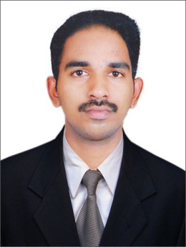

AABU JAFIS  
East Riffa, Kingdom Of Bahrain Email : aabujafisvma@gmail.com  
Contact : +973 34360819 Nationality : Indian C P R : 910149569 Date Of birth : Feb, 01, 1991 Status : Married Gender : Male Passport No : J2668156

**OBJECTIVE**

Seeking opportunities in a progressive company, which will provide challenging work environment, will help me grow professionally and at the same time making notable contributions to the company.

**WORK EXPERIENCE**

**Second Cup Coffee Company, Bahrain**

[January 2016 – Present]

Store In charge

Juffair Mall Branch

**Al Read House For Food Stuff**

**6 Months**[August 2015 – January 2016]

Salesman,

East Riffa, Bahrain

**City Silks Fashion Store**

**2 Years and 3 Months** [February 2013 – May 2015]

Salesman

Ernakulam, Kerala, India

**Image Studio**

**2 Years and 2 Months** [November 2010 –January 2013]

Video and Photo Editor

Kannur, Kerala, India

**Sree Sankaracharya Computer Centre**

**10 Months** [October 2009 – August 2010]

Teaching Faculty

Kannur, Kerala, India

**LANGUAGE KNOWN**

English

Malayalam

**EDUCATION QUALIFICATION**

|  |  |  |  |
| --- | --- | --- | --- |
| Course | Board /University | Percentage | Year |
| Diploma In Multimedia | Sree Sankaracharya  Computer Centre | 90% | 2009 |
| Intermediate(12th) | Kerala State Senior Secondary School | 50 % | 2008 |
| High school (10th) | Kerala State Secondary School | 50 % | 2006 |

**SKILLS**

Knowledge of Making Coffee

Knowledge of Videos and Photos Editing

Knowledge of Computer MS Office, Excel etc.

Computer Basics

Working Knowledge of a readymaid field

**DECLARATION**

I hereby declare that the above mentioned are true to the best of my knowledge and belief.

Aabu Jafis

SIGNITURE